1. Which of the following statements is true regarding strictly Binary Tree?

A strictly binary tree with n leaves with ( n – 1) nodes

**A strictly binary tree with n leaves with ( 2n – 1) nodes**

A strictly binary tree with n leaves with ( 2n) nodes

A strictly binary tree with n leaves with ( 2n + 1) nodes

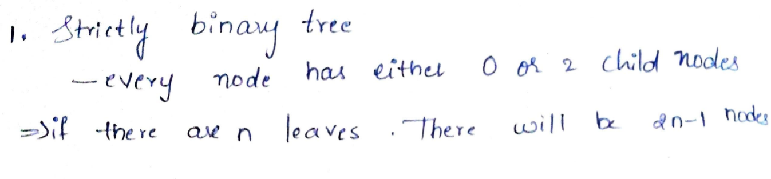

2. What will be the output of the following code?

1. char str[20]

2. Integer s

3. set str = “PQRSTUVWXYZ”

4. s = string_ length(str)

5. str[3] = NULL

6. s = strlen(str)

7. Print s

[Note : The string_ length() function calculates the length of a given string]

4

**3**

2

None

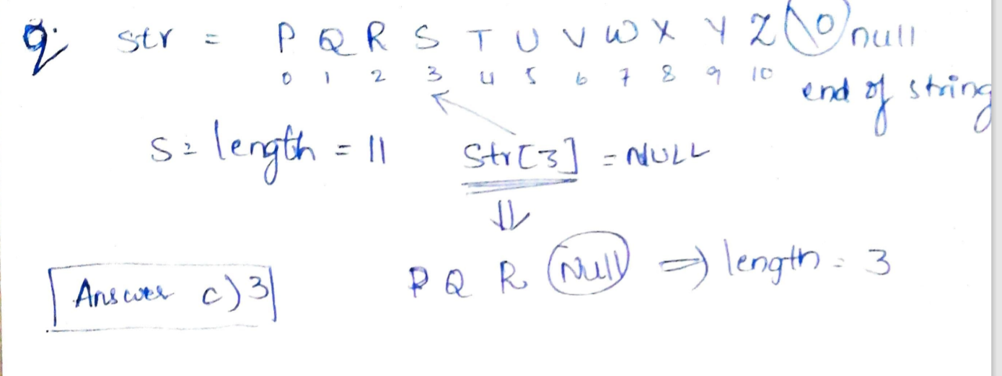

3. What will be the output of the following pseudo code for n = 1?

1. void reverse ( int n)

2. if( n greater than 5 )

3. exit

4. print n

5. return reverse( Increment n by 1)

6. end function reverse()

It will print 1 infinite times

None of the mentioned options

1 2 4 6 8

**1 2 3 4 5**

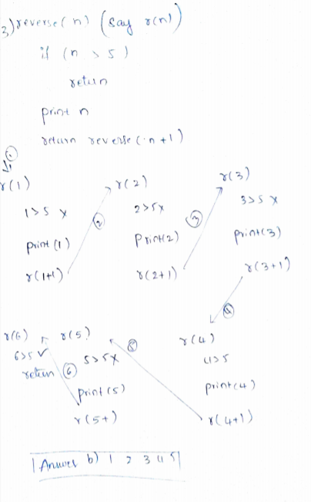

4. What will be the output of the following pseudo code?

1. Integer arr1[10], n, ctr, p, q, r

2. set arr1[] = {1, 2, 3, 4, 5, 2, 6, 5, 9}, n = 9, ctr = 0

3. for( each p from 0 to n -1)

4. ctr = 0

5. for(each q from 0 to p – 2)

6. if(arr1[p] = arr1[q])

7. ctr = ctr + 1

8. end if

9. end for

10. for(each r from p + 1 to n – 1)

11. if(arr1[p] = arr1[r])

12. ctr = ctr + 1

13. end if

14. end for

15. if (ctr EQUALS 0)

16. print arr1[p]

17. end if

18. end for

**None of the mentioned options**

1 3 4 6 9

1 2 3 4 5 6 9

2 5

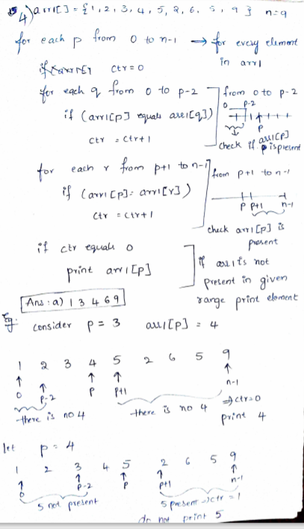

5. Consider a Binary tree having two pointers for each of its children. These pointers are set to NULL if the corresponding child is empty. How many NULL pointers does a binary tree with 'N' nodes have?

**N+1**

The number depends on the shape of the tree

N

N-1

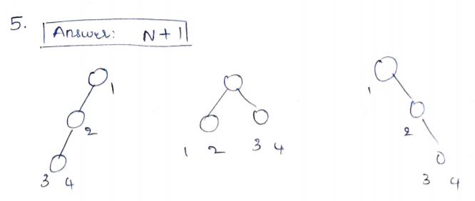

6. What will be the output of the following pseudo code?

1. Integer x, y, z, a

2. set x = 2, y = 1, z = 5

3. a = ( x AND y) OR ( z + 1)

4. print a

5

**1**

3

2

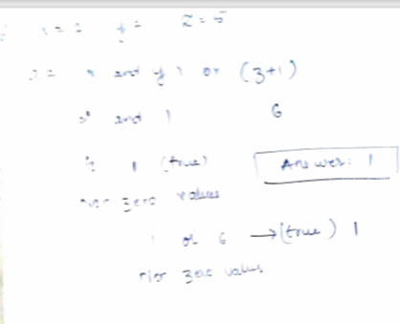

7. What will be the output of the following pseudo code for a = 10, b = 6?

1. Integer func(Integer a, Integer b)

2. Integer temp

3. while(b)

4. temp = a MOD b

5. a = b

6. b = temp

7. end while

8. return a

9. } [/ code

10.

11. [ Note: while(b) means the loop will execute until the b is non – zero]

4

3

1

**2**

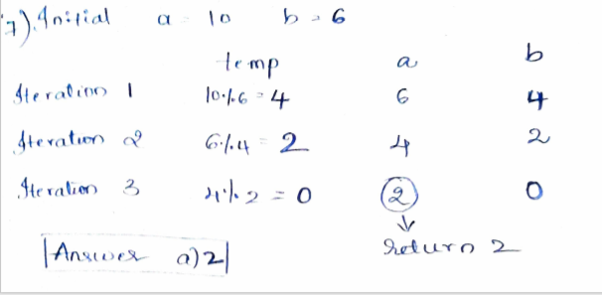

8. What will be the output of the following pseudo code?

1.Declare x, y, i

2.Set x = 0, y = 2

3.for i = 6 to x

4.y = y * 1

5.Print y

6.i = i - 1

7.End for

4 8 16 32 64 128 128

None of the mentioned options

**2 2 2 2**

2 4 8 16 32 64 64

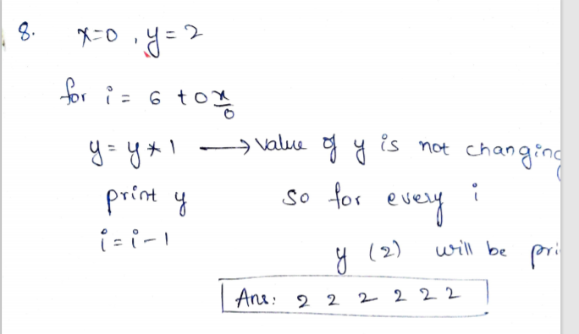

9. What will be the output of the following code?

1. Integer a, b, c, d

2. set a = 8, b = 7 , c = 4, d = 6

3. a = b + c – d

4. b = a + d – c

5. d = a + b + d

6.

7.print d

**18**

8

3

12

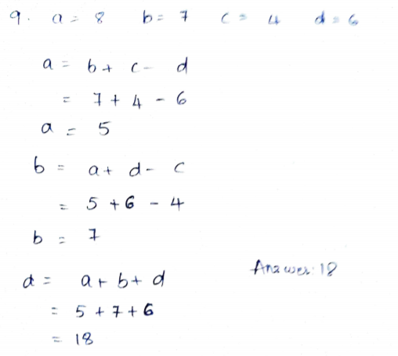

10. What will be the output of the following pseudo code for n = 91?

1. int fun ( int n)

2. if ( n > 100)

3. return n – 10

4. return fun ( fun ( n + 11))

**91**

121

110

99

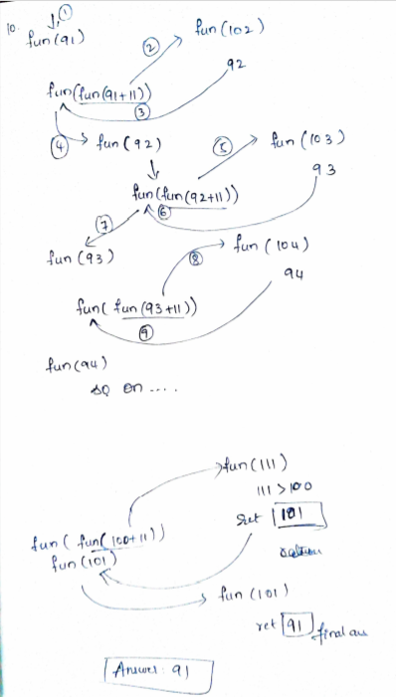

11. What will be the output of the following pseudo code?

1. Integer x, y, z

2. set x = 24, y =8

3. x = x / y

4. z = y << x

5.Print z

[Note: << is left shift operator, it takes two numbers, left shifts the bits of the first operand, the second operand decides the number of places to shift]

1

0

8

**64**

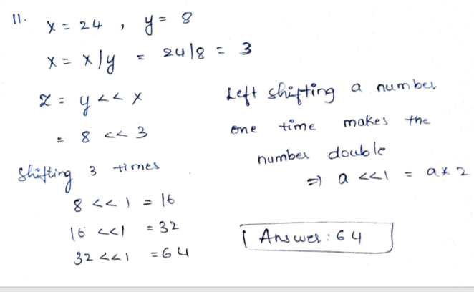

12. If a complete binary min- heap is made by including each integer in [ 1, 1023] exactly once. The depth of a node in the heap is the length of the path from the root of the heap to that node. Thus the root is at depth 0. The maximum depth at which integer 9 can appear:

None

9

**8**

log 9

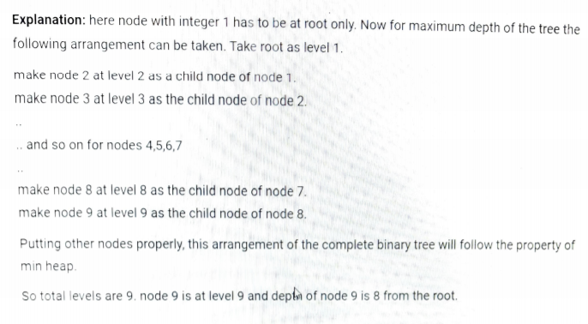

13. Given below is the pre order traversal sequence of a binary search tree, what would be the post order traversal sequence of the same tree?

30, 20, 10, 15, 25, 23, 39, 35, 42

15, 20, 10, 23, 25, 42, 35, 39, 30

Cannot be determined

**15, 10, 23, 25, 20, 35, 42, 39, 30**

15, 10, 25, 23, 20, 42, 35, 39, 30

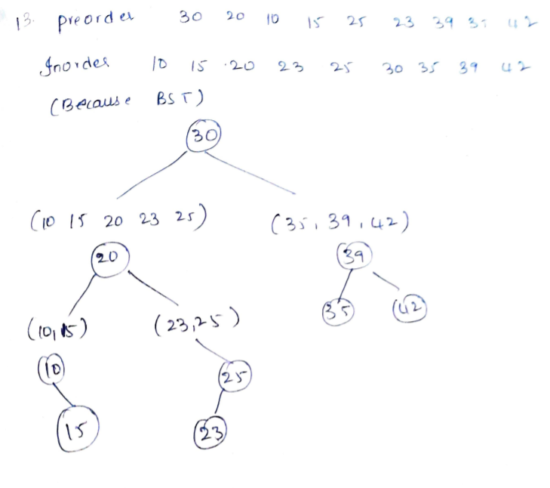

14. What will be the output of the following pseudo code?

1. Integer x, y, z, a

2. set y = 2

3. set x = ( y = y * 2 ) + ( z = a = y)

4. print x

7

5

9

**8**

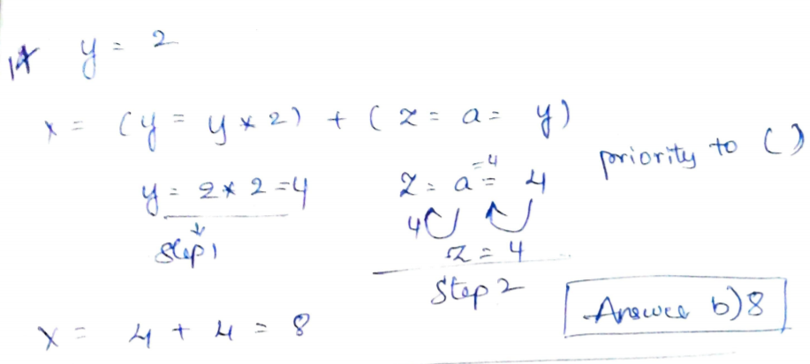

15. How many times “A” will be printed?

1. integer i, j

2. for(each i from 0 to 4)

3. for(each j from 0 to 3)

4. if( i > 1)

5. Jump out of the loop

6.end if

7. end for

8. Print A

9. End for

Seven

**Five**

Four

Six

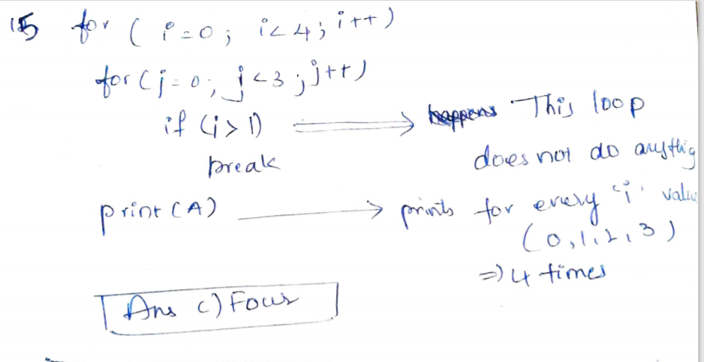

16. What will be the output of the following pseudo code?

1. Integer i, j, sum

2. set sum = 0

3. for ( i = 0 to 5)

4. for ( j = 0 to 2)

5. sum = i * j

6. end for

7. end for

8. print sum

27

**10**

None

15

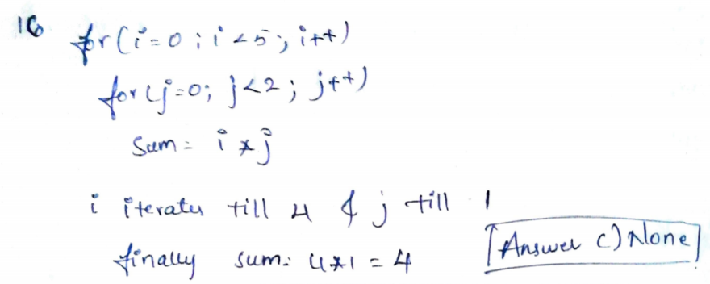

17. What will be the output of the following pseudo code?

1. Integer a = 2, b = 6, c, i

2. c = ( a + b ) – 3

3. for (each i from 0 to c – 1)

4. a = a – i

5. c = c + a

6. end for

7. print c

2

0

-3

**3**

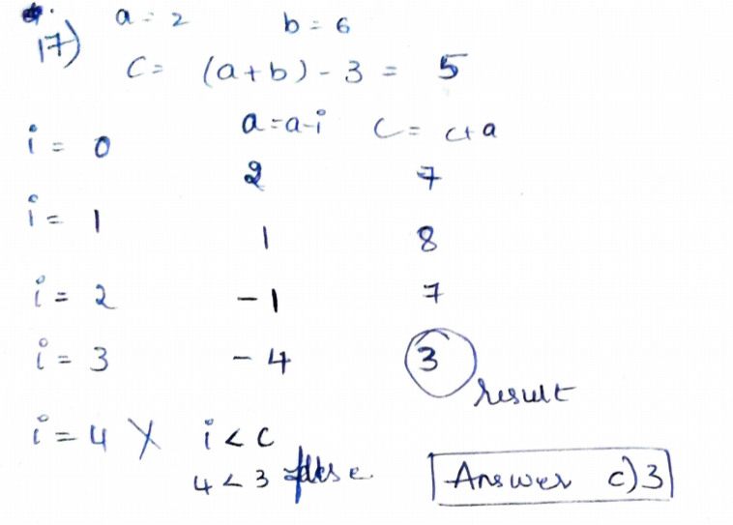

18. What will be the output of the following pseudo code for c = 1?

1. Integer fun( Integer c)

2. print c

3. if(c < 3)

4. c = c + 2

5. fun ( fun c)

6. end if

7. return c

8. end function fun

1 3 5 5

1 3 3 3

**1 3 3**

None of the mentioned options

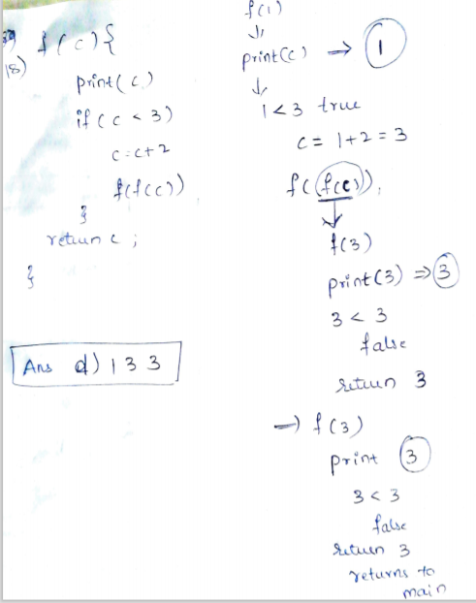

19. What will be the output of the following pseudo code?

1.Integer a, b, i, c, n, j

2.Set a = 0, b = 1, n = 3

3.For(each i from 1 to n)

4.a = 0

5.b = 1

6.Print b

7.for(each j from 1 to i – 1)

8.C = a + b

9.Print c

10.a = b

11.b = c

12.End for

13.Go to next line

14.End for

A.3 C. 3

2 3 3 2

1 2 3 3 2 1

B.1 D. 1

1 1 1 2

1 1 2 1 2 3

**B**

A

C

D

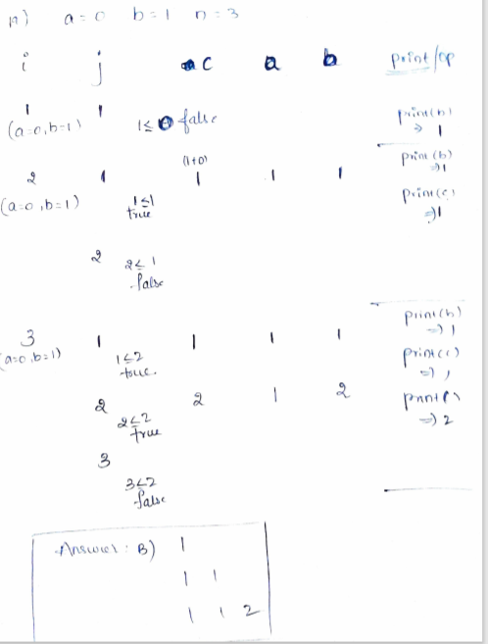

20. How many times A will be printed for n = 5?

1. def fun1(int n)

2. Integer i

3. set i =0

4. If ( n greater than 1)

5. fun1( n – 1)

6. for(each i from 0 to n -1)

7. print “ A”

14

**15**

13

17

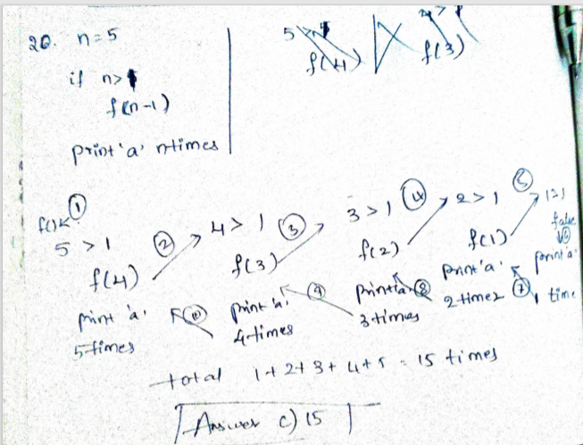

21. Which of the following is the correct number of minimal AVL tree of height 6?

15

**20**

None

6

22. What will be the output of the following pseudo code?

1. Integer a, b, count

2. set a = 2, count = 0, b = 1

3. while ( b < 121)

4. b = a * b

5. count = count +1

6. b = b + 1

7. end while

8. print count

120

7

**6**

127

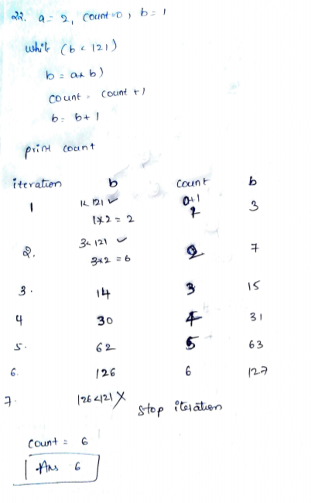

23. What will be the output of the following pseudo code?

1. Integer rows = 4, k, l, number = 1

2. for(each k = 1 to rows)

3. for(each l = 1 to k)

4. Print number

5. Print space

6. number = number + 1

7. end for

8. Move to next line

9. end for

A.1 2 3 4 B. 1

1 2 3 1 1

1 2 1 2 1

1 1 3 3 1

C. 1 D. 1

2 3 2 3 2

4 5 6 3 4 5 4 3

7 8 9 10 4 5 6 7 6 5 4

**C**

A

B

D

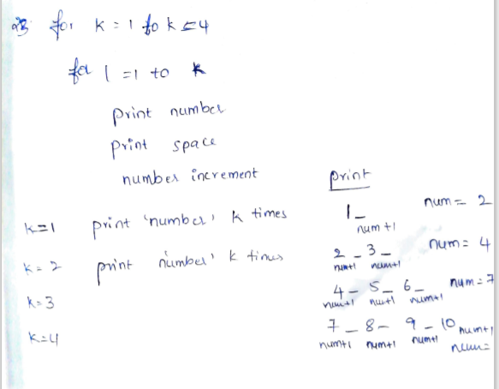

24. What will be the output of the following pseudo code?

1. Integer x

2. set x = 259

3. if ( x EQUALS 0)

4. print “0”

5. otherwise if( x MOD 9 EQUALS 0)

6. print “9”

7. otherwise

8. print x MOD 9

9. end if

None

8

**7**

16

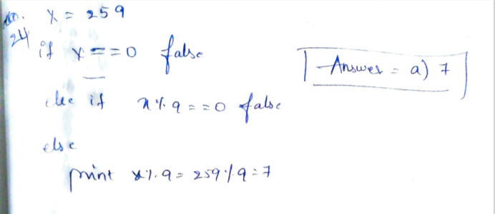

25. What would be the output of the following pseudo code for a =2, b = 3?

1. doSomething(Integer a, Integer b)

2. if ( b EQUALS 1)

3. return 0

4. else

5. return a + doSomething(a, b – 1)

6. End function doSomething()

2

**4**

1

3

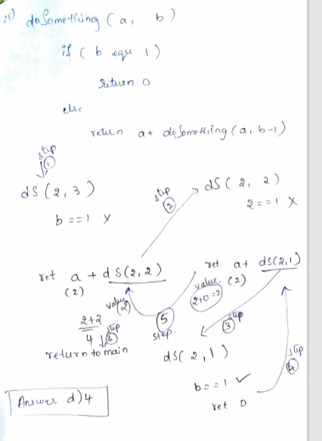

1. How much time will be required to generate all the connected components in an undirected graph G with ‘n’ vertices and ‘e’ edges when the graph is represented by an adjacency list?

1. O(n)
2. **O(e + n)**
3. O(e)
4. O(e^2)

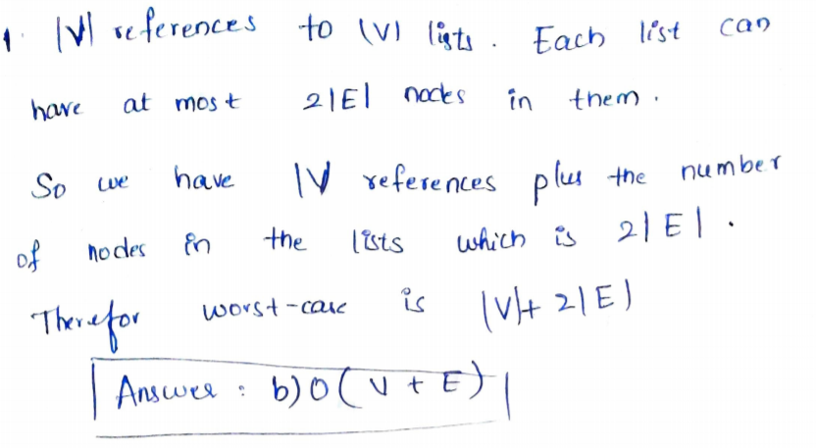

2. What will be the output of the following pseudo code for a = 10, b = 6?

1. Integer func(Integer a, Integer b)

2. Integer temp

3. while(b)

4. temp = a MOD b

5. a = b

6. b = temp

7. end while

8. return a

9. } [/ code

10.

11. [ Note: while(b) means the loop will execute until the b is non – zero]

1. **2**
2. 3
3. 4
4. 1

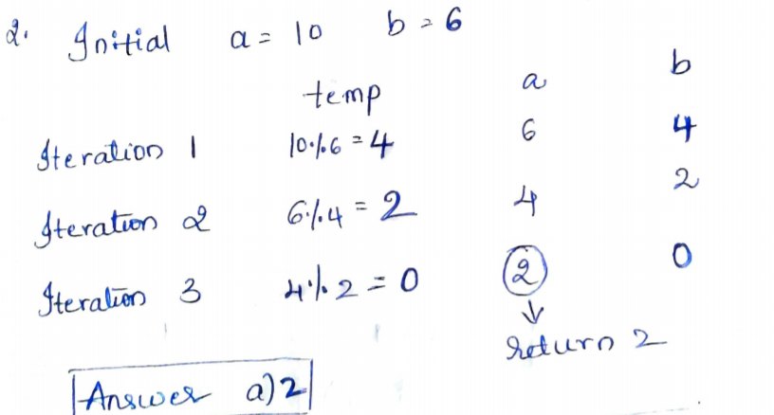

3. What will be the output of the following code?

1. char str[20]

2. Integer s

3. set str = “PQRSTUVWXYZ”

4. s = string_ length(str)

5. str[3] = NULL

6. s = strlen(str)

7. Print s

[Note : The string_ length() function calculates the length of a given string]

1. 2
2. 4
3. **3**
4. None

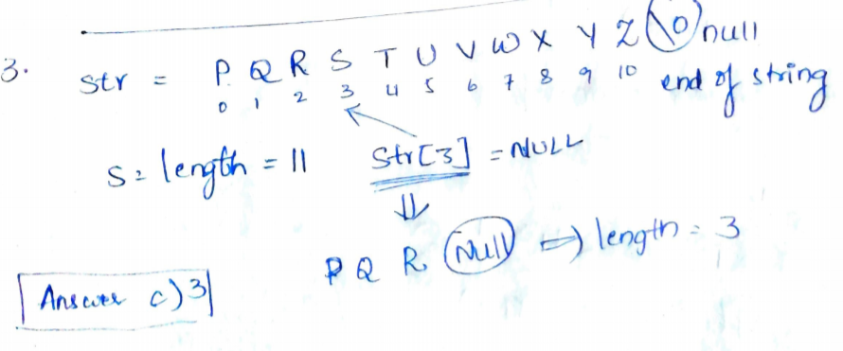

4. What will be the output of the following pseudo code?

1. Integer a = 2, b = 6, c, i

2. c = ( a + b ) – 3

3. for (each i from 0 to c – 1)

4. a = a – i

5. c = c + a

6. end for

7. print c

1. 0
2. 2
3. **3**
4. -3

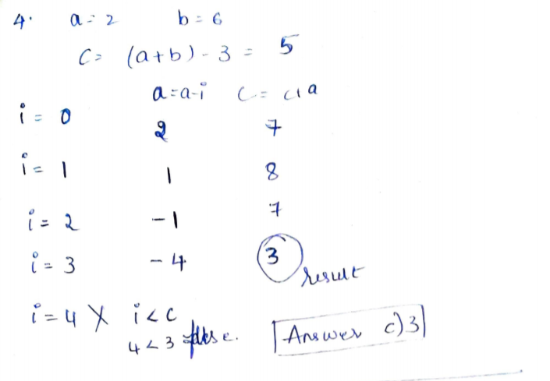

5. The process of accessing data stored in the tape is similar to manipulating data on a:

1. Queue
2. Set
3. **Stack**
4. List

6. How many times A will be printed for n = 5?

1. def fun1(int n)

2. Integer i

3. set i =0

4. If ( n greater than 1)

5. fun1( n – 1)

6. for(each i from 0 to n -1)

7. print “ A”

1. 17
2. 14
3. **15**
4. 13

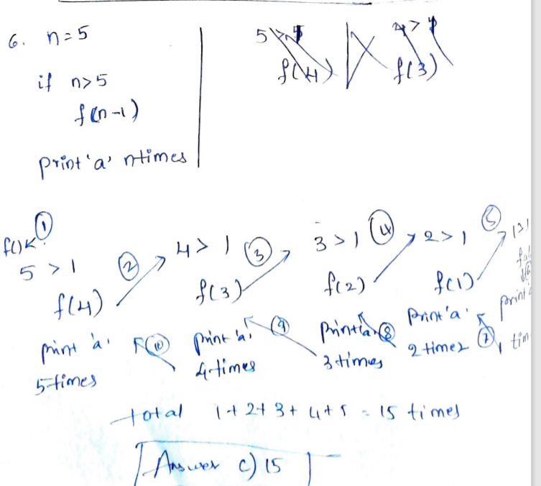

7. To which of the following domain problems does the Knapsack problem belong?

1. Optimization
2. Linear solution
3. **NP-Complete**
4. Sorting

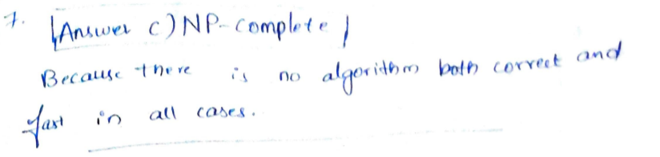

8. What will be the output of the following pseudo code?

1. Integer x, y, z, a

2. set y = 2

3. set x = ( y = y * 2 ) + ( z = a = y)

4. print x

1. 9
2. **8**
3. 7
4. 5

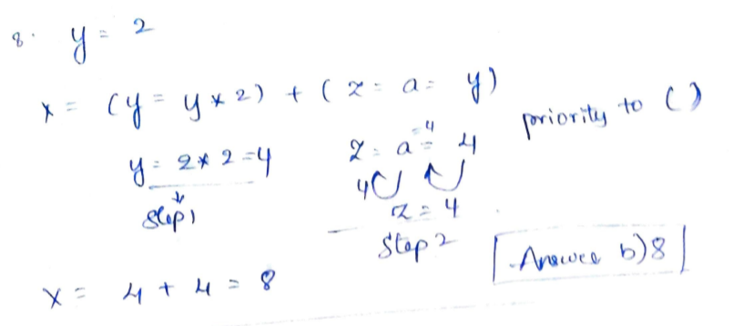

9. Which of the following is required for converting an infix expression to postfix expression efficiently?

1. A parse tree
2. An operand stack
3. **An operator stack**
4. An operator stack An operand stack

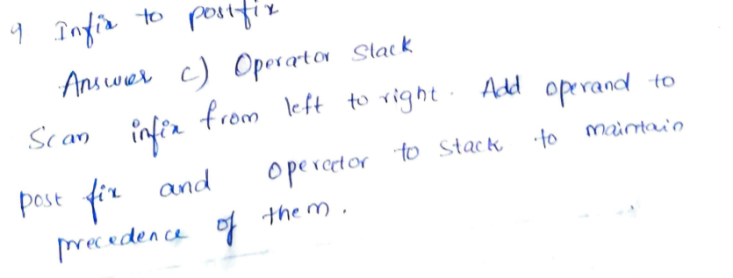

10. What will be the output of the following pseudo code?

1. Integer x

2. set x = 259

3. if ( x EQUALS 0)

4. print “0”

5. otherwise if( x MOD 9 EQUALS 0)

6. print “9”

7. otherwise

8. print x MOD 9

9. end if

1. **7**
2. 8
3. 16
4. None

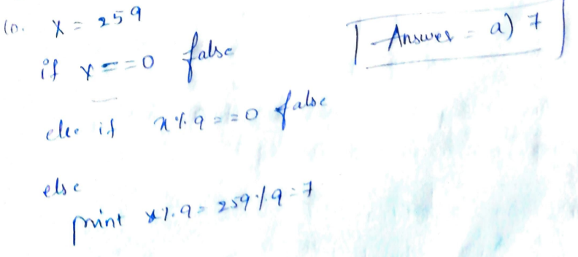

11. What will be the output of the following pseudo code?

1. Integer i, j, sum

2. set sum = 0

3. for ( i = 0 to 5)

4. for ( j = 0 to 2)

5. sum = i * j

6. end for

7. end for

8. print sum

1. 15
2. 27
3. **None**
4. 10

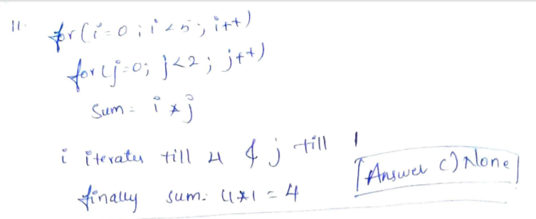

12. How many times “A” will be printed?

1. integer i, j

2. for(each i from 0 to 4)

3. for(each j from 0 to 3)

4. if( i > 1)

5. Jump out of the loop

6.end if

7. end for

8. Print A

9. End for

1. Five
2. Six
3. **Four**
4. Seven

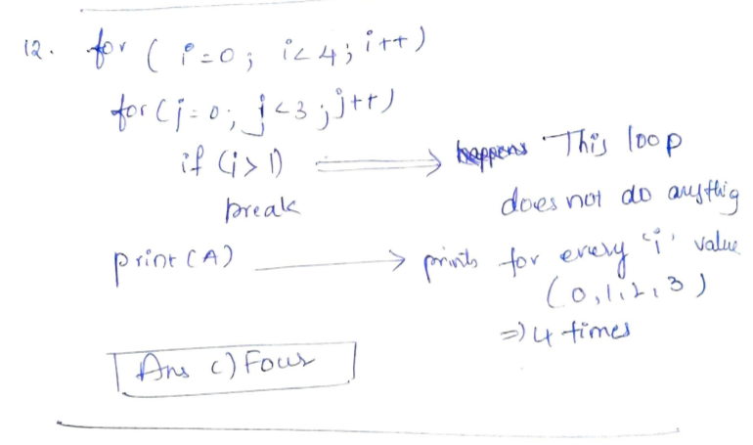

13. For which of the following purposes, the given pseudo code can be used?

1. Start

2. Read n

3. for k = 1 to n

4. r = k mod 7

5. if r not equal to 0

6. print k

7. stop

1. None of the mentioned options D.
2. To print all the integer from I to n those are divisible by 7
3. **To print all integers from 1 to n omitting those integers which are divisible by 7**
4. To print the maximum number from 1to n which is not divisible y 7

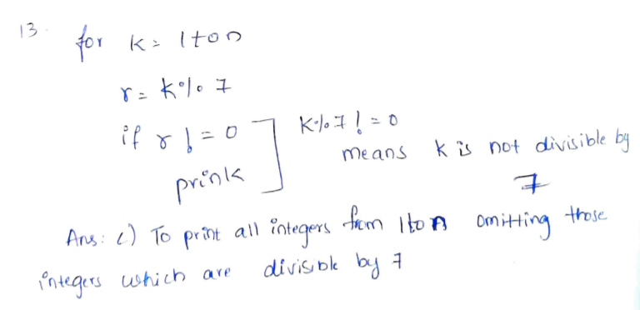

14. Which of the following statements is/are correct about conversion of an expression infix operation to postfix expression?

1.The order of number remains unchanged between infix and postfix.

2.The order of operators remains unchanged between infix and postfix.

3.At least 2 stacks are required to convert an infix expression to postfix expression

Choose the correct answer from the options given below.

1. Only 1
2. Only 1 and 3
3. **Only 1 and 2**
4. All 1, 2, and 3

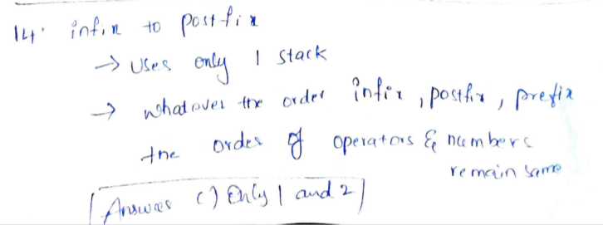

15. What will be the output of the following pseudo code?

1. Integer arr1[10], n, ctr, p, q, r

2. set arr1[] = {1, 2, 3, 4, 5, 2, 6, 5, 9}, n = 9, ctr = 0

3. for( each p from 0 to n -1)

4. ctr = 0

5. for(each q from 0 to p – 2)

6. if(arr1[p] = arr1[q])

7. ctr = ctr + 1

8. end if

9. end for

10. for(each r from p + 1 to n – 1)

11. if(arr1[p] = arr1[r])

12. ctr = ctr + 1

13. end if

14. end for

15. if (ctr EQUALS 0)

16. print arr1[p]

17. end if

18. end for

1. **1 3 4 6 9**
2. None of the mentioned options
3. 2 5
4. 1 2 3 4 5 6 9

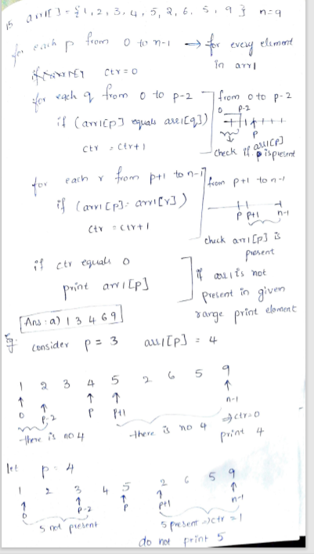

16. Which of the following is/are the advantages of a chained hash table (external hashing) over the open addressing method?

1. None of the mentioned
2. **Deletion is easier**
3. Worst case time complexity of the search operation is less
4. Efficiency use the space.

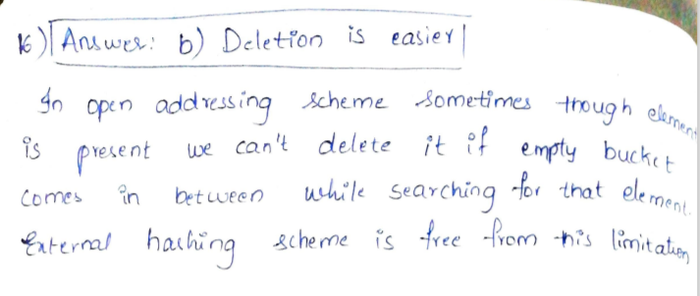

17. Find the possible permutations which can be obtained in the output (in the same order) with the help of stack data structure assuming that the input is in the sequence 1, 2, 3, 4, 5 in that order

1. 3, 4, 5, 1, 2
2. 1, 5, 2, 3, 4
3. 5, 4, 3, 2, 1
4. **3, 4, 5, 2, 1**

18. Which of the following algorithms is easily adaptable to singly linked list?

1. All of the mentioned options
2. **Insertion sort**
3. Quick sort
4. Merge sort

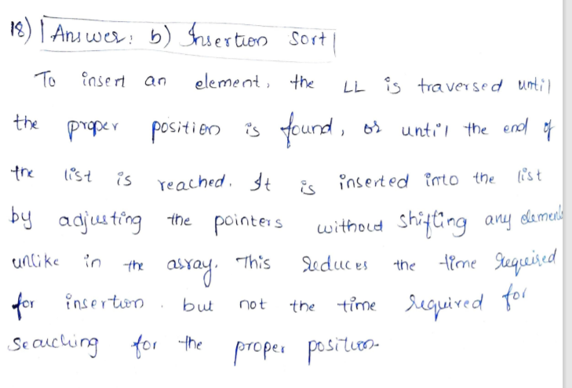

19. What will be the output of the following pseudo code?

1.Integer a, b, i, c, n, j

2.Set a = 0, b = 1, n = 3

3.For(each i from 1 to n)

4.a = 0

5.b = 1

6.Print b

7.for(each j from 1 to i – 1)

8.C = a + b

9.Print c

10.a = b

11.b = c

12.End for

13.Go to next line

14.End for

A. 3 C. 3

2 3 3 2

1 2 3 3 2 1

B.1 D. 1

1 1 1 2

1 1 2 1 2 3

1. A
2. **B**
3. D
4. C

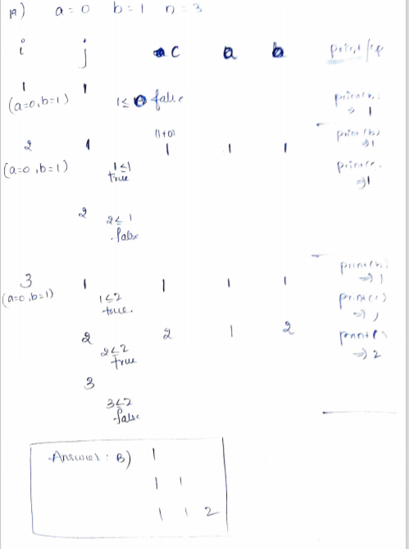

20. What will be the output of the following pseudo code for c = 1?

1. Integer fun( Integer c)

2. print c

3. if(c < 3)

4. c = c + 2

5. fun ( fun c)

6. end if

7. return c

8. end function fun

1. 1 3 3 3
2. None of the mentioned options
3. 1 3 5 5
4. **1 3 3**

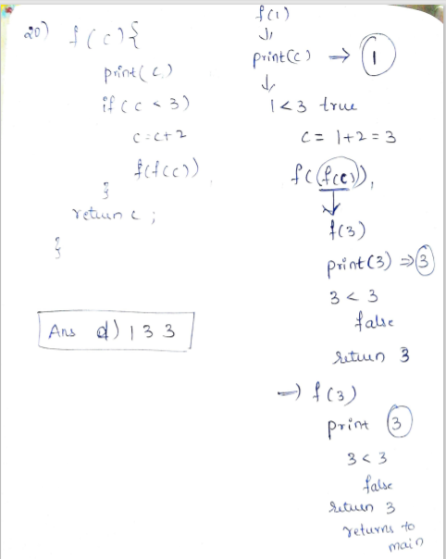

21. Which of the following data structure is used in case of recursion?

1. Array
2. Queue
3. **Stack**
4. Heap

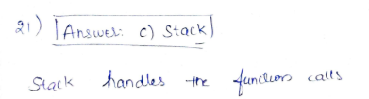

22. Consider the pseudo code mentioned below, for which of the following inputs, the pseudo code ill print successful?

1.num = 6

2.num = 4

3.num = 7

1. Integer num, t, f

2. t = num

3. f =0

4. while ( t NOT EQUALS 1)

5. if( t MOD 2 NOT EQUALS 0)

6. f = 1

7. jump out of the loop

8. end if

9. t = t / 2

10. end while

11. if( f EQUALS 0)

12. print “Successful”)

13. else

14. print “ unsuccessful”

15. end if

1. All 1, 2 and 3
2. Only 2
3. Only 1 and 3
4. **Only 1 and 2**

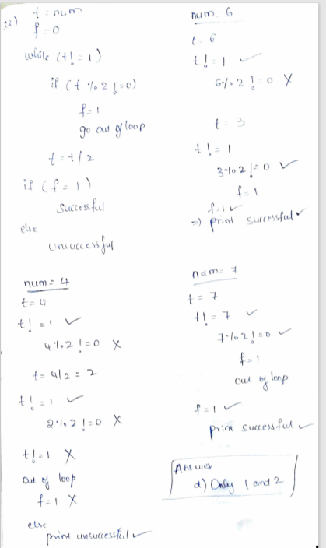

24. What will be the output of the following pseudo code for n = 1?

1. void reverse ( int n)

2. if( n greater than 5 )

3. exit

4. print n

5. return reverse( Increment n by 1)

6. end function reverse()

1. None of the mentioned options
2. **1 2 3 4 5**
3. It will print 1 infinite times
4. 1 2 4 6 8

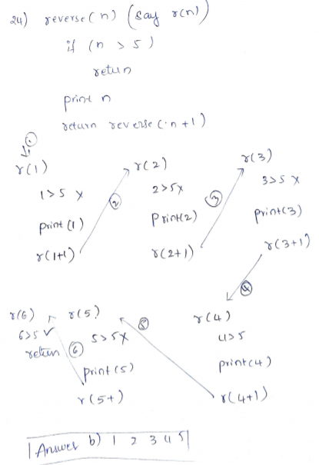

25. What would be the output of the following pseudo code for a =2, b = 3?

1. doSomething(Integer a, Integer b)

2. if ( b EQUALS 1)

3. return 0

4. else

5. return a + doSomething(a, b – 1)

6. End function doSomething()

1. 1
2. 2
3. 3
4. **4**

